|  |  |  |  |
| --- | --- | --- | --- |
|  | Bansilal Ramnath Agarwal Charitable Trust's  Vishwakarma Institute of Information Technology  **Department of**  **Artificial Intelligence and Data Science** | | |
| Student Name: Siddhesh Dilip Khairnar | | | |
| Class: SY | Division: B | | Roll No: 272028 |
| Semester: 3rd | | Academic Year: 2022 - 23 | |
| Subject Name & Code: ADUA21206: Data Visualization | | | |
| Title of Assignment: **Visualize**  **the dataset using temporal category and Timelines tools** | | | |
| Date of Performance: | | Date of Submission: | |

Aim: Visualize the dataset using spatial file and hex map.

## Problem Statement:

1. Describe what is spatial dataset.
2. Describe what is shape file (.shp file) and its use.
3. Create Hex map using a spatial dataset and appropriate .shp file. 4.Point out important observations from visualization.

Dataset:

Link: [https://community.tableau.com/s/news/a0A4T000001v7OPUAY/hex-](https://community.tableau.com/s/news/a0A4T000001v7OPUAY/hex-tile-map-files) [tile-map-files](https://community.tableau.com/s/news/a0A4T000001v7OPUAY/hex-tile-map-files)

Link2 : [https://www.kaggle.com/datasets/bravehart101/sample-supermarket-](https://www.kaggle.com/datasets/bravehart101/sample-supermarket-dataset) [dataset](https://www.kaggle.com/datasets/bravehart101/sample-supermarket-dataset)

Background Information:

Dataset:

* 1. Here I used the dataset of Sample store sales which is provided on Kaggle. And Connected it with the Hex State spatial File .
  2. This Dataset Contains the profit sales quantity and much more insights which help in plotting the graphs.
  3. It is a Detailed Dataset about Customer Id, Name so it is easy to keep insights of the customer which is buying anything from store.

**Spatial Files in Tableau:** It relating to the enjoyment or study of beauty, or showing great beauty. In Tableau Desktop, you can connect to the following spatial file types: Shapefiles, MapInfo tables, KML (Keyhole Markup Language) files, GeoJSON files, TopoJSON files, and Esri File Geodatabases. You can then create point, line, or polygon maps using the data in those files.

### Hex State Charts:

Hex Maps have become the standard when visualizing data where the sizing of the geographical region is unimportant. Hex tile maps are a good option in the cases where it would be great to get rid of the different sizes of each region. Basically, in a tile map all areas will have the same size. The original shape will be changed to a hexagon and the location will be relatively preserved to each area. It is somewhat Similar to the geospatial Representation of the data in such a way that audience can be easily find the main moto of the presentation which the person wants to explain them.

# Visualizations:

## **Observation:** We created a Hex Map and from this we get a clear idea about the Geospatial representations of the states and the profit and sales gained by each of the sub category product in the region.

We also able to determine the variety between the products because of the different color combinations we had given to them we can clearly figure out that how much profit does a product gained in less no. of sales.

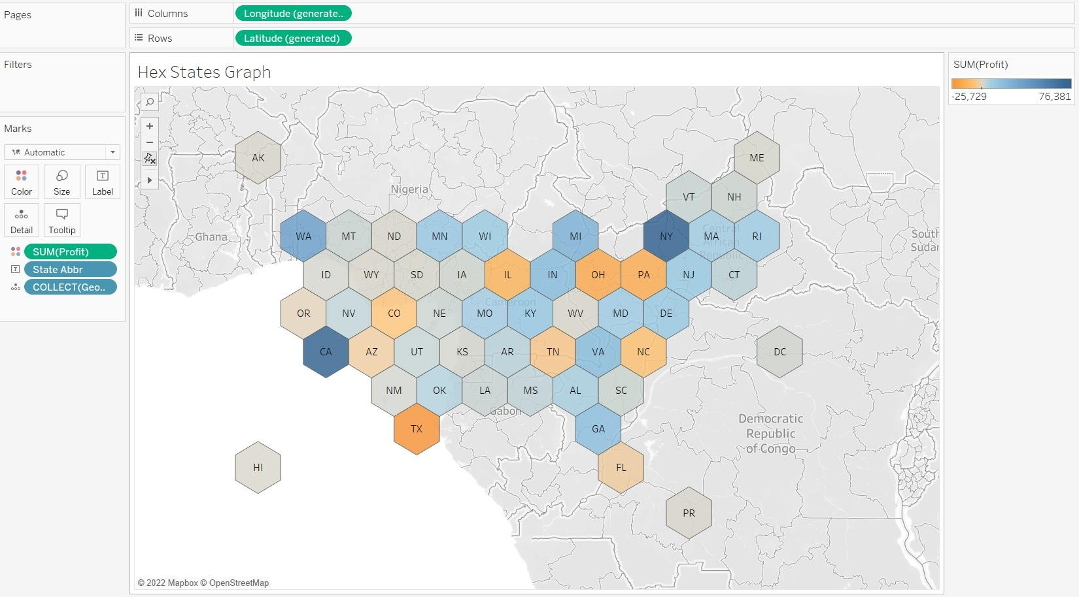

### Advantages:

1. Helps to determine the charts on Geospatial representations
2. Helps a person to give a analysis of the company in the large range of the area.
3. Helps to set clear priorities and directions so that the most critical tasks are cleared.

# Tableau Link :

<https://public.tableau.com/app/profile/siddhesh.dilip.khairnar/v> [iz/Assign9_16707399739400/Sheet1?publish=yes](https://public.tableau.com/app/profile/siddhesh.sunil.mali/viz/Assign9_16707399739400/Sheet1?publish=yes)

# Conclusion:

Here we Learned how to use the spatial files in the tableau and connect it with the dataset we can also do the union of that file to create a hex map visualization. This helps us in the geostavisualizations. This which can cover a wide range of area which helps any company analysis their data over a long range. So, I conclude that I Successfully connected the spatial file and implemented the hex map.